D. Michael Heinekey

Professor, Department of Chemistry, University of Washington Seattle, WA 98195-1700
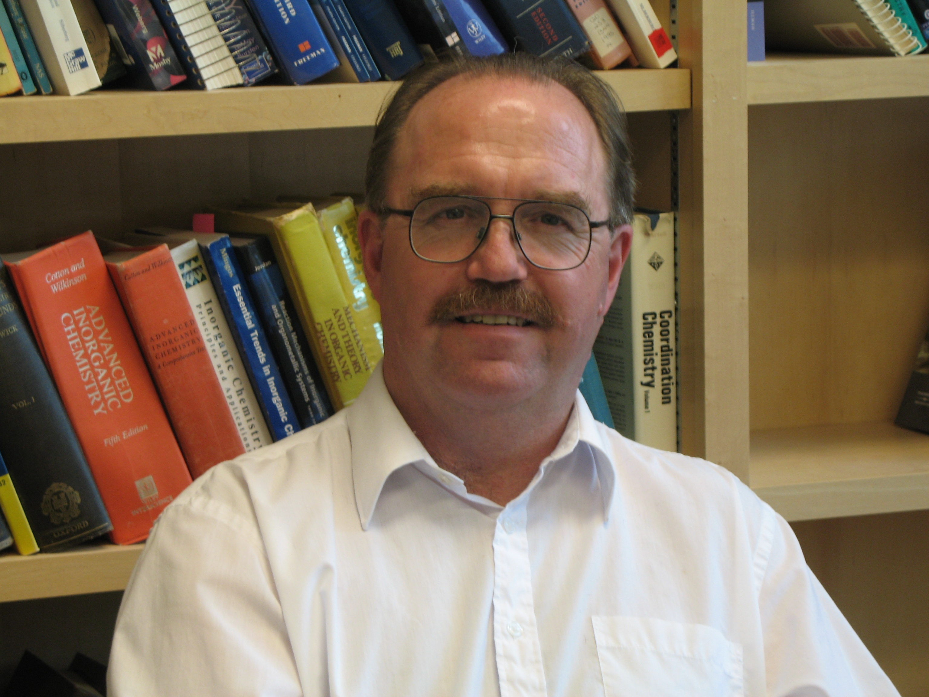
E-mail: heinekey@chem.washington.edu; Tel: 206-543-7522; 206-543-1613.
US and Canadian citizen; DOB April 19/55

Professional Preparation
NSERC Postdoctoral Fellow, UC Berkeley, Berkeley, CA, 1982-1984 (Earl Muetterties)
Ph.D., University of Alberta (W. A. G. Graham), 1982; B.Sc., University of Victoria, 1977

Appointments
2015-Present: Chair, Department of Chemistry, University of Washington
1995 – Present: Professor, Department of Chemistry, University of Washington.
1992-1995: Associate Professor, Department of Chemistry, University of Washington.
1989-1991: Associate Professor, Department of Chemistry, Yale University.
1985–1989: Assistant Professor, Department of Chemistry, Yale University

Research Interests: Inorganic chemistry; Homogeneous catalysis; Hydrogen storage; Energy conversion
Selected Recent Publications (of ≈120 total)
“An Improved Synthesis of ^{Me4}PCP and DMPE” Travis T. Lekich, Phoebe G. Askelson, Ryan K. Burdick, and D. M Heinekey. Organometallics, 2018, 37, 211.
“Detection of an Iridium-Dihydrogen Complex: A Proposed Intermediate in Ionic Hydrogenation.” Jonathan Goldberg, Karen I. Goldberg, D. M. Heinekey, Samantha A. Burgess, David B. Lao, John C. Linehan. J. Am. Chem. Soc., 2017, 139, 12638.
“Hydride and dihydrogen complexes of earth abundant metals: structure, reactivity and applications to catalysis.” Samantha J. Connelly Robinson, D. M. Heinekey. Chem. Comm., 2017, 53, 669.
“Structure of a Novel Rhodium-Phosphinite Compound: Agostic Interactions as a Model for an Oxidative Addition Intermediate.” Sophia D. Cherry; W, Kaminsky; D. M. Heinekey. Organometallics 2016, 35, 2165.
“High Catalytic Efficiency Combined with High Selectivity for the Aldehyde-Water Shift using (para-cymene) Ruthenium Precatalysts. Timothy P. Brewster, Jeremy C. Tran, Jonathan Goldberg, Karen I. Goldberg. ACS Catalysis, 2016, 6302.
“The Importance of Steric Factors in Iridium Pincer Complexes.” Jonathan M. Goldberg, Gene W. Wong, McKenzie Brastow, Werner Kaminsky, Karen I. Goldberg and D. M. Heinekey. Organometallics, 2015, 34, 753.
“Iridium, Rhodum and Ruthenium Catalytst for the “Aldehyde-Water Shift”Reaction”. Timothy P. Brewster, William C. Ou, Jeremy C. Tran, K. I. Goldberg, Susan K. Hanson, Thomas R. Cundari and D. M. Heinekey ACS Catalysis, 2014, 4, 3034.
“Structure and Solution Reactivity of Triethylsilylium-Triethylsilane Cations” Samantha J. Connelly, Werner Kaminsky and D. M. Heinekey. Organometallics, 2013, 32, 7478.
“Catalytic Disproportionation of Formic Acid to Generate Methanol” Alexander J. M. Miller, D. M. Heinekey, J. M. Mayer and Karen I. Goldberg. Angew. Chem. Int. Ed., 2013, 52, 4073.
“Hydrogenation of Carboxylic Acids Catalyzed by Half-Sandwich Complexes of Iridium and Rhodium” Timothy P. Brewster, Alexander J. M. Miller, D. M. Heinekey and Karen I. Goldberg. J. Am. Chem. Soc. 2013, 135, 16022.
“Partial Deoxygenation of Glycerol Catalyzed by Iridium Pincer Complexes” David B. Lao, Alisa Owens, D. M. Heinekey and Karen I. Goldberg. ACS Catalysis, 2013, 3, 2391.
“Alkane Dehydrogenation by C-H Activation at an Ir^{III} Complex” Kate R. Allen, D. M. Heinekey, Alan. S. Goldman and Karen I. Goldberg. Organometallics, 2013, 32, 1579.
“C-H Bond Activation by Cationic NHC Iridium(III) Complexes: A Combined Experimental and Computational Study.” Joseph M. Meredith, Robert Robinson, Jr., Karen I. Goldberg, Werner Kaminsky, and D. M. Heinekey Organometallics, 2012, 31, 1879.
“Dihydrogen Complexes of Iridium and Rhodium” Michael Findlater, Katherine M. Schulz, Wesley H. Bernskoetter, Alison Cartwright-Sykes, D. Michael Heinekey and Maurice Brookhart Inorg. Chem. 2012, 51, 4672.
“Partial Deoxygenation of 1,2 Propanediol Catalyzed by Iridium Pincer Complexes.” Takiya J. Ahmed Foskey, D. Michael Heinekey, Karen I. Goldberg ACS Catalysis, 2012, 2¸1285.
“Synthesis, Structure and Reactivity of a Nickel Dihydrogen Complex” Samantha J. Connelly, Amanda C. Zimmerman, Werner Kaminsky and D. Michael Heinekey Chem. Eur. J. 2012, 15932.
“Synthesis, Characterization and Reactivity of Iridium NHC Pincer Complexes” Katherine M. Schultz, Karen I. Goldberg, Dmitry G. Gusev and D. Michael Heinekey. Organometallics, 2011, 30, 1429.
.“Preparation of a Dihydrogen Complex of Cobalt” Travis J. Hebden, Anthony J. St. John, Dmitry G. Gusev, Werner Kaminsky, Karen I. Goldberg, D. Michael Heinekey.” Angewandte Chemie 2011, 50, 1873.
“Hydrogenase Enzymes: Recent Structural Studies and Active Site Models.” D. M. Heinekey J. Organomet. Chem. 2009, 694, 2671.

