【无机化学论坛】 **The Beauty of Molecules**

报告: **Prof.**  **Shie-Ming Peng**

Department of Chemistry, National Taiwan University,

Institute of Chemistry, Academia Sinica.

时间：2019年5月9日（周二） 下午14:00—15:30

地点：北京大学化学学院A区717报告厅.

**Abstract:**

The lecture is prompted by the paper of Prof.Roald Hoffmann (The Journal of Aesthetics and Art Criticism, 48, 191-204, 1990) and bead work of my colleague, Prof. Bih-Yaw Jin. The intention of the lecture is to introduce the structural chemistry to general audiences. Many beautiful molecules are presented by drawing, picture or real 3D model instead of difficult chemist’s language. After simple introduction of chemical bond, many molecules are showing from organic molecules to inorganic molecules, coordination complexes and organometallic complexes. Then giant molecules, proteins, DNA seven virus will be illustrated. The final remark will be focused on my research molecules: metal string complexes. These molecules are fundamentally important in the study of metal-metal bonding and also have great potential applications as molecular electronics.

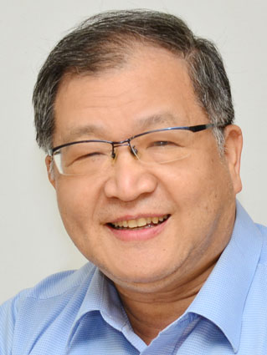Curriculum Vitae

**Name:** PENG, SHIE-MING

**Date of Birth:** March 2, 1949

**E-mail:** smpeng@ntu.edu.tw

**Tel:** 886-2-2363 8305

**Fax:** 886-2-8369 3765

**Address:** Department of Chemistry National Taiwan University

No.1, Sec. 4, Roosevelt Rd., Taipei, Taiwan, R.O.C. 10617

**Educational and Professional**

National Taiwan University B.S. 1970

The University of Chicago Ph.D. 1975

Northwestern University Post doctor 1975-1976

**Current Position and Relevant Experience**

National Taiwan University Professor 1980-Now

Universitaet Muenster, Germany Visiting Professor 2012

Academia Sinica Vice President 2011-2014

Universite de Strasbourg (ULP) , France Visiting Professor 2009

Institute of Molecular Science, Japan Visiting Professor 2008

Chuo University, Japan Visiting Professor 2004

University of Zaragoza, Spain Visiting Professor 2003

Chemical Society Located in Taipei President 2001-2002

Universite Louis Pasteur, France Visiting Professor 2000

National Taiwan University Vice President 1999-2002

Institute of Molecular Science, Japan National Laboratory Visiting Scholar 1991

Department of Chemistry, National Taiwan University Chairman 1987-1990

Institute of Chemistry, Academia Sinica Acting Director 1985-1987

Max-Planck Institute of Solid State Research Humboldt Fellow 1983-1984

National Taiwan University Associate Professor 1976-1980

**Honors and Awards**

Humboldt Fellow 1983

Outstanding Young Alumni, National Taiwan University 1985

Sun-Yat Sen Foundation, Academic Award 1991

Chinese Chemical Society (Taipei), Academic Award 1992

Ho Foundation, Academic Award 1996

National Science Council, Outstanding Research Award 1986; 1988; 1990; 1993

National Science Council, Distinguished Researcher 1995; 1998

Ministry of Education, Science Award 1996

Ministry of Education, Chair Professor 1997-2000

Member of Academia Sinica (Academician) 1998

Chang Foundation, Academic Award 2000

TWAS (The Third World Academy of Sciences) Prize in Chemistry 2002

Member of TWAS 2004

Phi Tau Phi Taiwan Chapter, Outstanding Achievement Award 2005

Y.Z. Hsu Scientific Chair Professor 2006

Taiwan-Frence Science Prize 2008

Chair Professor, National Taiwan University 2006; 2009; 2014

Fellow of the Royal Society of Chemistry 2009

International Award, Japan Society of Coordination Chemistry 2011

FACS, Foundation Lectureship Award 2011

Presidential Science Prize of Taiwan 2013

Luigi Tartufari International Chemistry Prize, Italin Academy of Sciences 2014

Russian Academy of Engineering, Foreign Member 2014

Japan Society for the Promotion of Science (JSPS), Fellow 2015

Distinguished Chinese Visiting Scholar Lectureship of Hong Kong Baptist University 2015