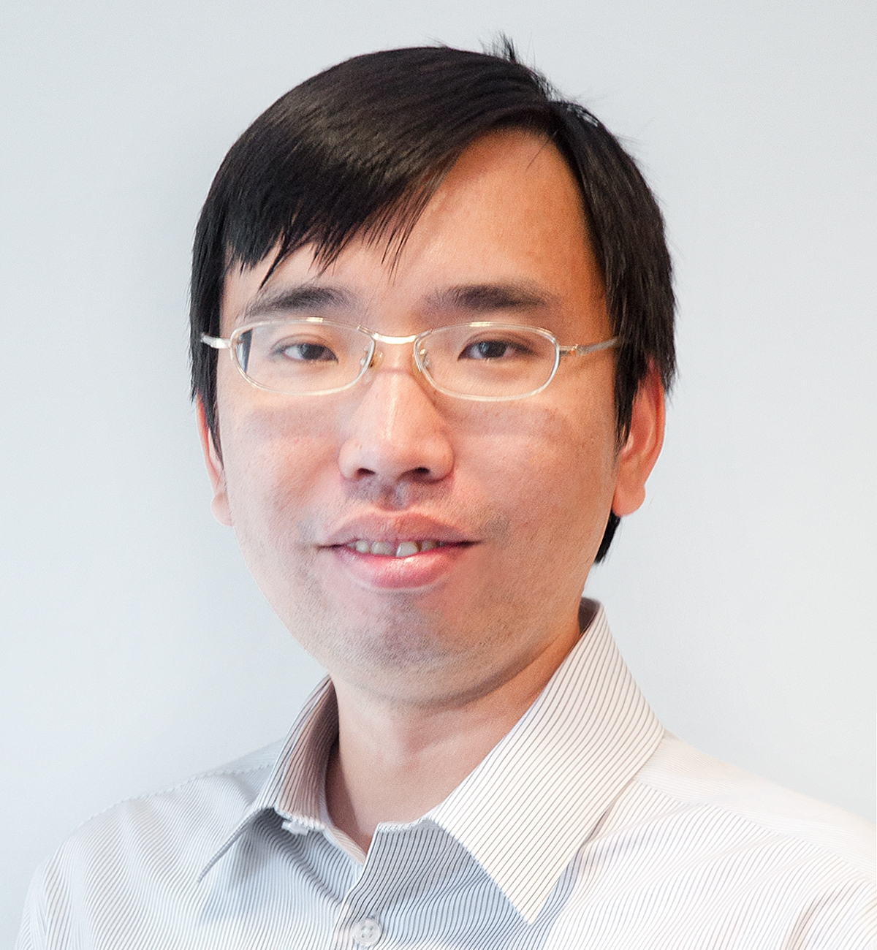

Professor Feng Jiao holds a BSc in Chemistry from Fudan University in China and a PhD in Chemistry from the University of St Andrews in the United Kingdom. Following the completion of his postdoctoral training at the Lawrence Berkeley National Laboratory, he joined the faculty at the University of Delaware in 2010. He is currently a Professor of Chemical and Biomolecular Engineering and serves as the Director of the Center for Catalytic Science & Technology. In August 2023, Professor Jiao joined the Department of Energy, Environmental & Chemical Engineering at Washington University in St. Louis as the Elvera and William R. Stuckenberg Professor. He also serves as the founding director of the Center for Carbon Management. The Jiao research group is dedicated to developing innovative electrochemical devices to address critical energy storage and sustainability challenges. Professor Jiao has published over 100 research papers, which have collectively received more than 17,000 citations. His contributions have been recognized with several awards and honors, including his election as a Fellow of the Royal Society of Chemistry, the receipt of the NSF CAREER Award, and recognitions as a 2020 Emerging Investigator by the Journal of Materials Chemistry A and a 2020 Scialog Fellow for the Negative Emission Science (NES) initiative.