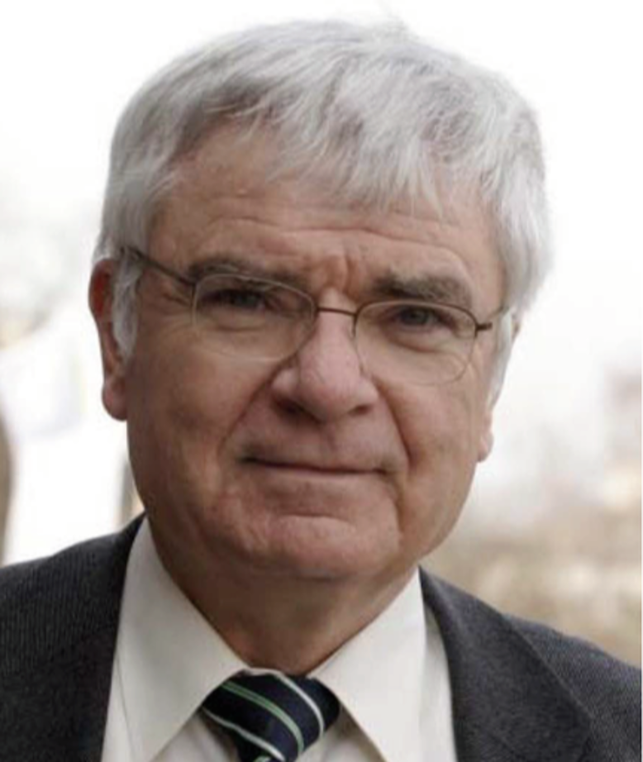

Prof. Jӧrn Manz is a member of German National Academy of Science Leopoldina, elected in 2009. He worked at the Free University of Berlin from 1992 until 2012 and was director of the Institute for Physical and Theoretical Chemistry from 1993 until 1999. He is one of the pioneers in the field of ultrafast femtosecond dynamics, contributing a series of groundbreaking works in ultrafast quantum dynamics of molecules and laser control of molecular quantum states. He has been invited to give talks at over 100 international conferences and was the founder of a series of International Conferences on Femtosecond Chemistry. In November 2012, the prestigious academic journal J. Phys. Chem. A published a special issue commemorating Prof. Manz's contributions to ultrafast femtosecond dynamics. Prof. Manz has close collaborations with Chinese academic institutions. Since January 2013 after his retirement from Free University of Berlin, he has been appointed as a distinguished professor at Shanxi University in Taiyuan.