**Why Crystals Will Save the World**

Mike Zaworotko

*Dept. of Chemical Sciences and Bernal Institute, University of Limerick, Ireland*

*Email: xtal@ul.ie*

That composition and structure can so profoundly impact the properties of crystalline solids has provided impetus for exponential growth in the field of *crystal engineering*1 over the past 30 years. This contribution will address how crystal engineering has evolved from its initial focus upon design (form) to its current emphasis on properties (function). Three classes of sorbent materials that offer new performance benchmarks will be presented:

* **Ultramicroporous adsorbents** offer exceptional control over pore chemistry, pore size and pore shape. New benchmarks for CO2 (see Figure), C2H2 and C6H6 have been observed2 thanks to tight binding sites and strong electrostatics associated with these coordination networks, which remain underexplored when compared to materials such as large pore MOFs. Studies that address atmospheric water harvesting will be presented.

**Figure.** CO2 capture by an ultramicroporous material2a

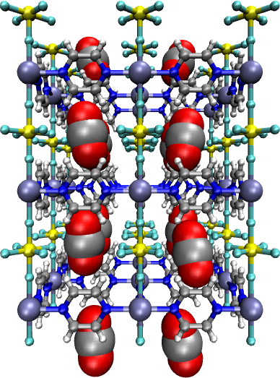

* **Flexible adsorbents** were once seen as a curiosity but it is now recognized that they can offer solutions to important gas storage and separation applications, especially when they reversibly switch from closed (non-porous) to open (porous) phases.3 New examples of functional flexible adsorbents will be discussed.
* **Sorption in non-porous solids.** Non-porous solids that undergo pressure-induced switching between closed and open phases are of interest for storage and separations applications.4 New examples of such “switching adsorbent materials” covering 0D, 1D and 2D materials will be covered.5

The overall goal of this presentation is to convey how and why crystal engineering can teach us how to custom design the right crystalline adsorbent for the right application, including what this means for global challenges such as carbon capture and water purification.

[1] Moulton, B.; Zaworotko, M.J. *Chemical Reviews* **2001**, *101*, 1629-1658.

[2] (a) Nugent, P.; *et al*. *Nature* **2013**, *495*, 80-84. (b) Cui, X.; *et al*. *Science*, **2016**, *353*, 141-144. (c) He, T. *et al.* *Nature Materials*, **2022**, *21*, 689-695.

[3] Wang, S.Q.; Mukherjee, S.; Zaworotko, M.J. *Faraday Discussions*, **2021**, *231*, 9-50.

[4] Nikolayenko, V. *et al*., *Nature Chemistry*, **2023**, *15*, 542-549.

[5] Rahmani, M., *et al.* *Journal of the American Chemical Society*, **2023**, *145*, 27316-27324.

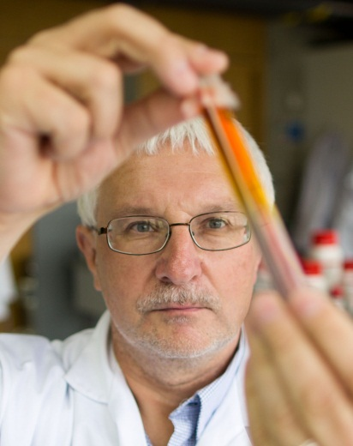**Michael Zaworotko**

Bernal Chair of Crystal Engineering

Member of the Royal Irish Academy

University of Limerick, Ireland

**Contact**

Office: AD2-021 (Analog Devices Building)

Phone: +353 61 234361  
Email: xtal@ul.ie

**Education**

B.Sc., ARCS, Imperial College, London, UK, 1977  
Ph.D., University of Alabama, Tuscaloosa, 1982 (J.L. Atwood)

Google Scholar: <http://scholar.google.com/citations?user=pKuYgikAAAAJ&hl=en&oi=ao>

ResearcherID: [http://www.researcherid.com/rid/A-7448-2009](https://legacy.usf.edu/owa/redir.aspx?C=NpBd57HYtkyl4NovQIdUb-rcqkvm8c9IE0zptnfb3E_7nX-0Gjz99p-zWpI-fz-VzxX-RL2jsiA.&URL=http%3a%2f%2fwww.researcherid.com%2frid%2fA-7448-2009)

Orcid ID: orcid.org/0000-0002-1360-540X

Twitter: @ZGroupUL

**Short Bio**

**Dr. Mike Zaworotko** was born in Wales in 1956 and received his B.Sc. and Ph.D. degrees from Imperial College (1977) and the University of Alabama (1982), respectively. He served as a faculty member at Saint Mary’s University (1985-1998), University of Winnipeg (1998-99), both in Canada, and at the University of South Florida, USA, (1999-2013). In 2013, he joined the University of Limerick, Ireland, where he currently serves as Bernal Chair of Crystal Engineering and was Co-Director of the SSPC from 2017-2022, [www.sspc.ie](http://www.sspc.ie).

Research activities have focused upon fundamental and applied aspects of **crystal engineering** since 1990. Currently, **metal-organic materials** (MOMs), **ultramicroporous physisorbents**, and **multi-component pharmaceutical materials** (MPMs), such as cocrystals, are of particular interest. These new materials are aimed at addressing global challenges such as carbon capture, water purification and improved medicines.

**Publications and Impact**

Dr. Zaworotko has published over 530 peer reviewed papers, book chapters and patents that have been cited over 63,000 times. H-index = 119. In 2011, Thomson-Reuters listed him as the 20th highest impact chemist since 2000, <http://archive.sciencewatch.com/dr/sci/misc/Top100Chemists2000-10/>, and in 2014, 2015, 2016 and 2018 he was listed as a highly cited researcher in the field of *Chemistry* by Clarivate Analytics: [www.highlycited.com](http://www.highlycited.com) In 2018, he was listed as a highly cited researcher in a second field, *Pharmacology and Toxicology*, whereas in 2019 and 2022 he was listed as a highly cited researcher in *Cross Field*.