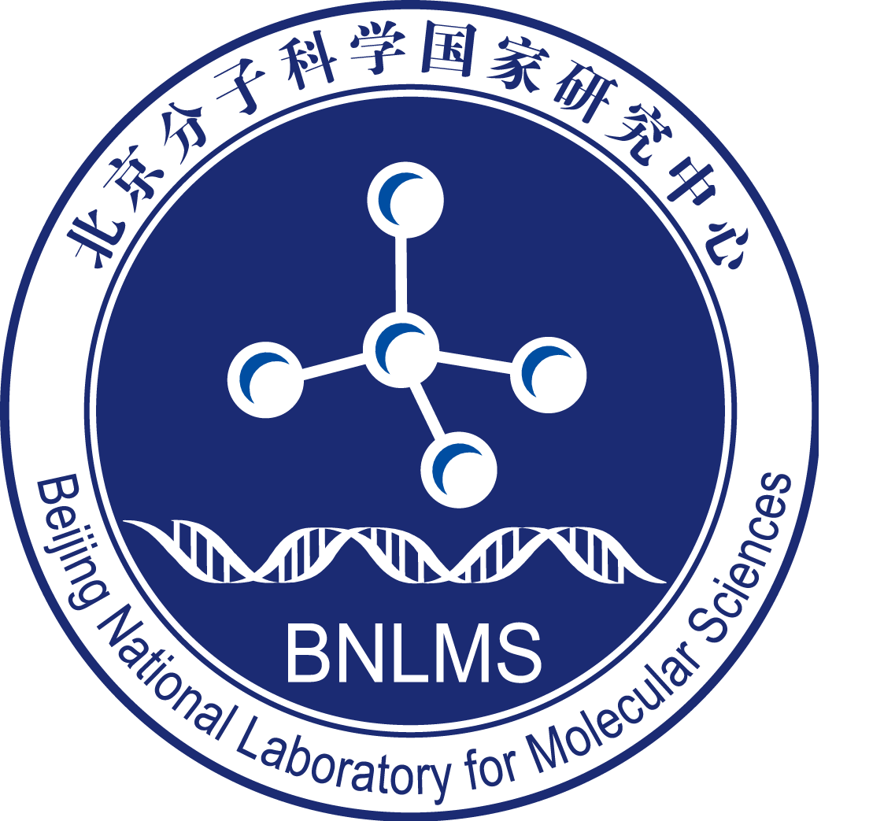

Application Form of BMS-Junior Fellowship, BNLMS
（2025）

Name：
Ph.D Granting Institution：
Postdoctoral Supervisor:
Funding period：
Contact： phone：？？？；email：？？？
apply for Boya postdoctoral at the same time Yes/ no
Date： Jun. 17, 2025

Beijing National Laboratory for Molecular Sciences
1. Basic Personal Information

1.1 Basic information
Name: XX; Gender: X; Date of birth: XX month, XXXX; ID number: XXXXX; Marital status: XXX
Doctor's graduation time, school, department and tutor: XX University, XX college, XX professor in XX month, XXXX;
Proposed tutor for postdoctoral cooperation: Professor XX;
Other postdoctoral program have been funded: (including the international exchange program, Boya postdoctoral program of PKU, BMS Junior Fellow of CCME, etc. and the program funding period. If not, please fill in "None")

1.2 Study and research experience:
(from undergraduate study experience, from the latest experience)

1. XX, XXXX – XX, XXXX, XX University, XX college, postdoctoral, tutor: Professor XX;
2. XX, XXXX – XX, XXXX, XX University, XX college, doctoral candidate, supervisor: Professor XX;
3. XX, XXXX – XX, XXXX, XX University, XX college, master's degree, tutor: Professor XX;
4. XX, XXXX – XX, XXXX, XX University, XX college, scientific research assistant, tutor: Professor XX;
5. XX, XXXX – XX, XXXX, XX University, XX college, undergraduate, tutor: Professor XX;

1.3 Teaching Assistant Experience and Class Hours

1.4 Publication of scientific research achievements: (fill in strictly according to the following format and list all authors, article titles, journal names, volume numbers and page numbers. One of them is marked #, and the corresponding or co corresponding author is marked with *. The name of the applicant is bold, and the DOI identification number is provided for the received but not published articles. Please mark review or preview at the end of the review or prospect papers. The first two items in the list are the most representative ones Tabular scientific research and academic achievements, no more than 10 items in total)

Examples
Journal Papers
Liming Tan#, Kelvin Xi Zhang#, Matthew Y. Pecot, Sonal Nagarkar-Jaiswal, Pei-Tseng Lee, Shin-ya Takemura, Jason M. McEwen, Aljoscha Nern, Shuwa Xu, Wael Tadros, Zhenqing Chen, Kai Zinn, Hugo J. Bellen, Marta Morey*, S. Lawrence Zipursky*, Ig Superfamily Ligand and Receptor Pairs Expressed in Synaptic Partners in Drosophila, Cell, 2015, 163(7): 1756-1769
Authorized invention patent
Format: inventor, patent name, authorization time, country, patent number
Example: Wang Fan, a traditional Chinese medicine composition for improving nutritional anemia and its preparation method, Nov. 19, 2014, China, zl201210020610.9
Conference Papers
Lou Y.#, Zhang H., Wu W., Hu Z., Magic view: An optimized ultra-large scientific image viewer for SAGE tiled-display environment, 9th IEEE International Conference on e-Science, e-Science 2013, Beijing, P.R. China, 2013.10.22-10.25
Special academic report of the conference
Jiang Zonglin, Experiments and Development of Long-test-duration Hypervelocity Detonation-driven Shock Tunnel , 2014 AIAA Science and Technology Forum and Exposition, National Harbor, Maryland , 13 - 17 January 2014
monograph
Format: all authors, title of Monograph (chapter title), publishing house, total words, year of publication.
Example: Xu Zhihong, Zhong Kang, plant cell differentiation and organogenesis, Science Press, 420000 words, 2015

1.5 Project / Topic: (no more than 5 items in total)

Hosting or participating in scientific research projects (Topics) (from the latest one):
Format: project category, approval number, name, research start and end date, supported amount, project status (closed or under research, etc.), Host or participate
For example: general program of National Natural Science Foundation of China, 21773999, ×××××××××， 2018 / 01-2021 / 12, 300000 yuan, closed, host

1.6 Academic awards: (no more than 5 in total)
Format: winners (ranking of winners / number of winners), name of award-winning project, award organization, award category, award level, award year (the list of all winners is attached)
Example: Li Lanjuan (1 / 15), theoretical innovation and technological breakthrough in the diagnosis and treatment of severe liver disease, Ministry of science and technology, National Science and technology progress award, first prize, 2013
(Li Lanjuan, Zheng Shusen, Chen Zhi, Li Jun, Wang Yingjie, Xu Kaijin, Xu Xiao, Chen Yu, Diao Hongyan, Du Weibo, Wang Weilin, Yao hangping, Wu Jian, Cao hongcui, pan Xiaoping)

1.7 Personal Academic Introduction （no more than 500 words）

2. Academic Achievements
2.1 Doctoral Dissertation
Title of the Doctoral Dissertation:
Abstract (no more than 500 words):

2.2 Representative Academic Achievements (no more than 300 words)

3. Postdoctoral Research Project
3.1 Title of Postdoctoral Research Project
3.2 Abstract of Postdoctoral Research Project (no more than 300 words)
3.3 Content of Postdoctoral Research Project (no more than 4000 wods) | Project summary  (1) Project context(including research significance, research overview and prospect in China and abroad, and importance of the proposed study. A list of references should be provided.)  (2) Project description, objectives, and the key scientific problems to be solved.  (3) Research approach and methodology, as well as feasibility analysis.  (4) Originality and innovative aspects of the proposed study.  (5) Annual research plan and expected results.

4. Applicant’s Commitment
I solemnly promise all the information that I submit above is true and is in accordance with academic morality. If the project is funded, I will fulfil the responsibilities of the applicant, strictly abide by the relevant regulations of BMS-Junior Fellow Project of BNLMS. Papers or other results published on the funded projects are endorsed by the Beijing National Laboratory for Molecular Sciences (BNLMS). If the report is incorrect and violates the regulations, I will take full responsibility.

Signature of the Applicant：
Date (yy/mm/dd):

5. Recommendation by Postdoctoral Supervisor
（Including the evaluation of scientific research ability of the applicant. If there are many co-supervisors, all teachers need to sign.）

If the applicant receives this support, I confirm that I will the take him/her as post doctor.

Signature of the Postdoctoral Supervisor：
Date (yy/mm/dd):

6. Recommendation by College of Chemistry and Molecular Engineering of Peking University
Signature of the Professor in Charge of Postdoctoral Affairs:
Stamp of CCME:
Date (yy/mm/dd):

7. Final Decision of BNMLS
Signatures of the members of the Selection Committee:
Date (yy/mm/dd):

8. Attachment:
（representative research results, including no more than two full-text papers, one monograph, one authorized patent and one award.）

